Pokhara University

Level: Bachelor | Semester – Spring | Year : 2012
Programme: BE |  | Full Marks: 100
Course: Numerical Methods |  | Pass Marks: 45
 |  | Time : 3hrs.

Candidates are required to give their answers in their own words as far as practicable.
The figures in the margin indicate full marks.

Attempt all the questions.

 | - Find at least one root of x³- 2x-5=0 with accuracy 0.008% using Bisection method.  - Find a root of the equation 3x + sinx – e^{x} = 0 using secant method so that the relative error is less than 0.01%.. | 8  7
 | - Given the data points as below-  Estimate F(2.5) by applying Cubic Spline technique.  - The velocity distribution of the fluid near a flat surface is given below :  x : 0.1 0.3 0.5 0.7 0.9  v : 0.72 1.81 2.73 3.47 3.98  Using suitable interpolation formula obtain the velocity at x = 0.2 and 0.4. | 8  7
  i | 0 | 1 | 2 | 3
  X_{i} | 1 | 2 | 3 | 4
  F(X_{i}) | 0.5000 | 0.3333 | 0.2500 | 0.2000
 | - Evaluate the integral I = 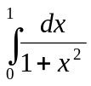 using Gauss quadrature formula with n = 2 and n = 3.  - Evalute 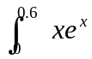using trapezoidal rule, simpson’s 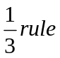and simpson’s r 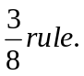Also state which method yields better result. | 8  8
 | - Solving the following system of Linear equations using L-U factorisation method.  x - 2y + z = 4  5x+ y -5z = 8  3x + 7y +4z =11  - Using Gauss –elimination method solve the equations:  2x + y + z = 4  4x + 2y + 3z = 4  x – y + z = 0 | 8  7
 | - Solve the following differential equation within 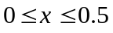using RK 4th order method. 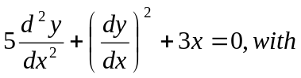y(0)=1 and y’( 0) = 0. (take h= 0.25)  - Solve the Poission equation 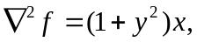over the square domain of 0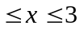 and 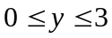 with 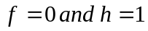 | 8  7
 | - Using Rung-Kutta method of fourth order, solve  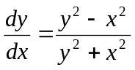 with initial condition y(0)=1 at x=0.2.  - Find the largest eigenvalue λ₁ and the corresponding eigen vector V₁ of the matrix.  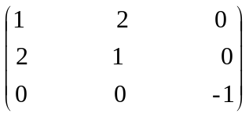 Using power method | 8  7
 | Write short notes on any two:  - Write the algorithm for the implementation of bisection method.  - Error in Numerical method  - Shooting method . | 2×5

